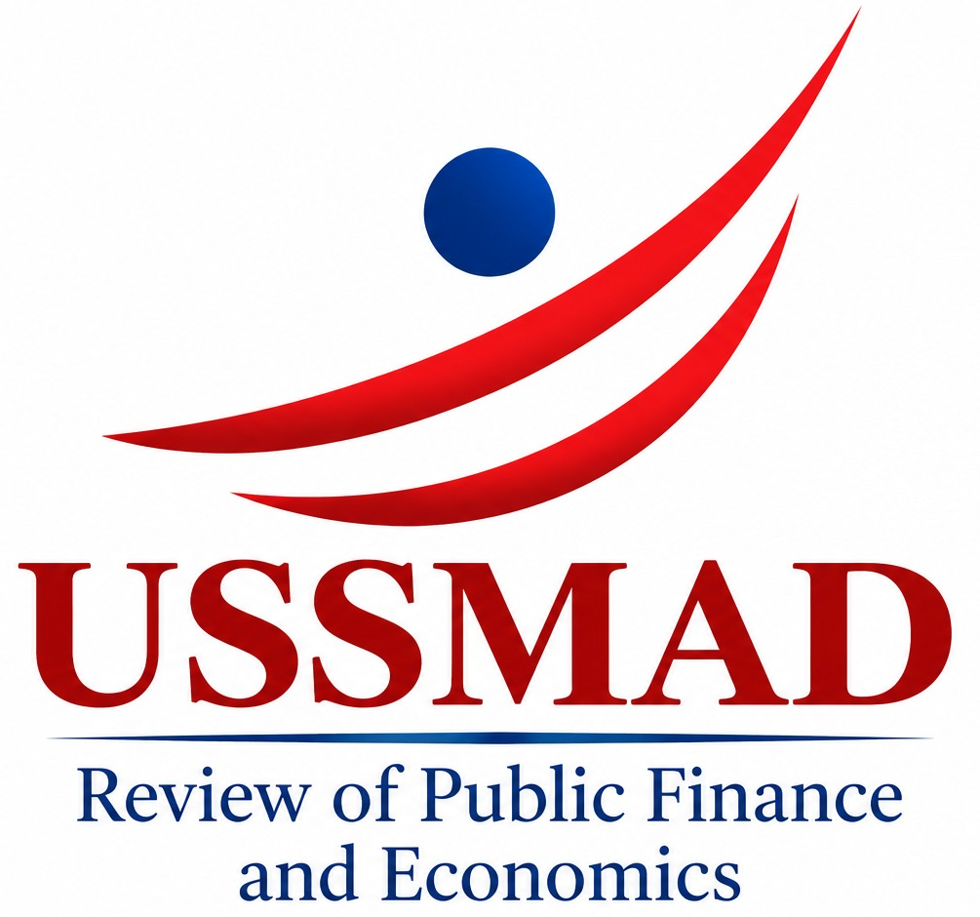 |  | Date: ....../………/……

Generative AI Use Declaration Form
For authors • To be submitted with the manuscript

This form follows the journal’s Generative AI Use and Academic Responsibility Policy. A separate AI declaration is not mandatory for routine spelling, grammar, basic language editing or formatting only.
Manuscript title: __________________________________________________________________
Manuscript ID (if available): ______________ Corresponding author: _______________________

1 Use status
Select one option.
☐ No generative AI was used.
☐ Use was limited to routine spelling, grammar, basic language editing or formatting.
☐ Generative AI was used for substantive purposes such as content generation, analysis, interpretation or coding; the disclosure below has been completed.

2 Disclosure of substantive use
Leave this section blank if there was no substantive use. Repeat the fields for additional tools.
Tool name and provider (version if available):
________________________________________________________________________________
________________________________________________________________________________
Purpose and scope (relevant sections, tables, figures, analyses or code):
________________________________________________________________________________
________________________________________________________________________________
How outputs were reviewed and verified (including source, data and analysis checks):
________________________________________________________________________________
________________________________________________________________________________

3 Author confirmation
We accept responsibility for scientific accuracy, originality, source reliability, research data, and all text, tables, figures and supplementary materials. We declare that substantive AI use has been fully disclosed and the relevant outputs reviewed and verified. AI tools have not been listed as authors, and their outputs have not replaced independent, verifiable academic sources supporting scientific claims. Final scientific and ethical responsibility rests with the authors.
Author name | Date | Signature
All authors should sign; add rows or a continuation sheet as needed.
Politika / Policy: https://dergipark.org.tr/tr/pub/ussmadreview/page/22136

